PROPERTY RENTAL LISTINGS
@CREATIVITY THINK (9483175986/7019689991)

ABSTRACT:
The Property Rental Listings platform is a web application designed for property brokers, rental agencies, and individual users to manage, search, and book rental properties efficiently. Users can filter listings, contact property owners, and make bookings, while administrators can manage property data, monitor bookings, and access analytics dashboards. Built with Django, Django Rest Framework, React, Leaflet, and Axios, this system provides real-time property data, interactive mapping features, and a centralized dashboard to enhance property management and streamline the rental process..

INTRODUCTION OF THE PROJECT:
Managing rental properties and connecting clients with suitable accommodations is challenging without an organized platform. The Property Rental Listings application allows users to search and filter properties, contact owners, and manage bookings through a web interface. Administrators can add and manage listings, monitor bookings, and track key analytics. The system combines Django and DRF for backend operations, React and Leaflet for frontend interactivity, and dashboards for analytics, providing a seamless experience for both users and administrators..

PROJECT OBJECTIVES:

• Provide a searchable and filterable property listing platform
• Enable users to contact property owners and book properties online
• Manage booking history and user dashboards for better engagement
• Allow administrators to add, edit, and manage property listings
• Monitor and analyze bookings through dashboard analytics
• Facilitate efficient communication between users and property managers
• Reduce manual effort in property rental operations
• Provide real-time mapping of properties via interactive maps

PROBLEM OF THE STATEMENT:
Property rental management often involves manual tracking, scattered listings, and poor communication between tenants and property owners. Without a centralized system, booking and filtering properties is inefficient, leading to delayed responses and missed opportunities. The Property Rental Listings platform resolves these issues by providing an interactive web interface, real-time listings, map-based search, and administrative dashboards, ensuring efficient property management and improved user experience..

MOTIVATION OF THE PROJECT:
• Streamline property search and booking for users
• Reduce manual effort in property rental operations
• Provide map-based property visualization
• Enable efficient admin control over listings and bookings
• Support data-driven insights via dashboards

BLOCK DAIGRAM OF PROJECT:

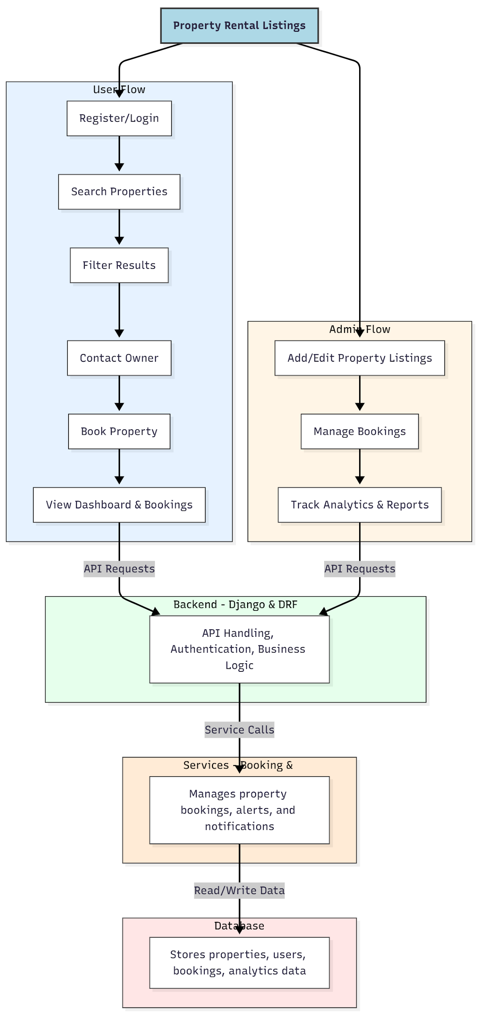

WORKING OF THE PROJECT:
Users first register or log in to the platform to search for available properties. They can filter results based on preferences, contact property owners, and complete bookings online. The dashboard allows users to view their booking history and manage appointments. Administrators add or edit property listings, manage bookings, and track analytics. The backend handles API requests, authentication, and business logic, while services manage booking processing, notifications, and alerts. The database stores property, user, and booking information for real-time tracking and reporting..

SOFTWARE REQUIREMENT:
- Backend:
  - Python 3.x
  - Django
  - Django REST Framework
  - SQLite/PostgreSQL
- Frontend:
  - Node.js and npm
  - React.js
  - Axios
- Development Tools:
  - Visual Studio Code
  - Postman (for testing APIs)
  - Git/GitHub (for version control)
- Server/Deployment (Optional):
  - Gunicorn, Nginx, or Heroku/AWS for hosting

ADVANTAGES OF THE PROJECT:

• Centralized property listing and booking system
• Interactive map-based search for users
• Streamlined communication between users and property owners
• Dashboard analytics for admins
• Reduces manual property management tasks
• Real-time tracking of bookings and availability
• Enhances operational efficiency for rental agencies
• Supports multi-user and multi-property management

APPLICATIONS OF THE PROJECT:
• Property brokers and agents
• Rental agencies
• Apartment and housing management
• Real estate marketplaces
• Vacation rental platforms
• Booking management for short-term rentals
• Analytics-driven property decision-making
• Interactive map-based property search

REFERENCES:

- Django REST Framework Documentation — Django Software Foundation. Django Documentation. Available: https://docs.djangoproject.com/
- Django REST Framework. DRF Documentation. Available: https://www.django-rest-framework.org/
- React. React Official Documentation. Available: https://reactjs.org/docs/getting-started.html
- Redux. Redux Documentation. Available: https://redux.js.org/introduction/getting-started
- PostgreSQL Global Development Group. PostgreSQL Documentation. Available: https://www.postgresql.org/docs/
- MySQL. MySQL Reference Manual. Available: https://dev.mysql.com/doc/
- Git. Git Documentation. Available: https://git-scm.com/doc
- Node.js. Node.js Documentation. Available: https://nodejs.org/en/docs/
- Axios. Axios Documentation. Available: https://axios-http.com/docs/intro
- Socket.io Documentation – https://socket.io/docs/

